Capstone Project Documentation

StaffFuel Food Hospital Application

Note: The following are the candidate sections of the document. They are presented here for guidance. Questions in each section could be used as possible aspects to cover. Some questions may not be applied to each project. On the other hand, additional information may be needed.

# Introduction

## Purpose

* **What is the problem or the opportunity that the project is investigating?**

Whether having a healthy food application for hospital staff that is responsive and easy to use will be able to help employees perform better at work, which in turn will improve patient care and outcomes, and improve the day-to-day operations. Hospital staff work long stressful hours and often don’t have the time or convenience to prepare their own food and therefore are more likely to adopt unhealthy food habits.

* **Why is this problem valuable to address?**

Improved overall health among hospital staff means improved focus, productivity, resilience, and performance which can positively impact patient care and outcomes.

Hospitals can reduce healthcare costs associated with poor nutrition.

* **What is the current state (e.g. unsatisfied users, lost revenue)?**

Unhappy and unhealthy healthcare workers because of short break times. Queues at the hospital cafeteria are long, resulting in healthcare workers going to other places nearby and choosing other food options that may or may not be healthy for them, leading to lost revenue for the hospital.

* **What is the desired state?**

Satisfied customers where they are able to order food at the tips of their fingers and not have to wait long in the queue to get their food. Their food will be ready for them to pick up once it is ready.

Improved overall health and wellbeing for all hospital staff leading to higher productivity and performance and better patient care, and less mistakes.

* **Has this problem been addressed by other projects? What were the outcomes?**

Other projects, such as Uber Eats and other companies have addressed this issue of making it easy for people to order their food online, giving them a range of options to choose from, however, this problem has not been addressed in the hospital context in relation to hospital staff only.

## Industry/ domain

* **What is the industry/ domain?**

Healthcare industry, Food Service Industry and the Technology industry

* **What is the current state of this industry? (e.g. challenges from startups)**

There has been a lot of digital transformation in healthcare where hospital food apps have emerged to offer nutritional guidance and enhance accessibility to provide health food options for all. There has also been a growing focus on health and wellness. Nutrition and technology are integrated together to help people make informed decisions about their food, help people track their nutrition and manage their dietary goals.

* **What is the overall industry value-chain? (tasks a company needs to performs to produce a valuable product.)**

1. Collaboration with various stakeholders such as hospitals, food service providers, and nutrition experts to help deliver comprehensive information and deliver high quality services.
2. Health promotion among hospital staff to allow them to adopt healthier eating habits.
3. Positive behavioural changes through education and the promotion of healthy eating by offering nutritional advice and tips to educate users about healthy food choices.

* **What are the key concepts in the industry?**

Health and wellness, convenience and accessibility (pre-ordering meals and delivery services), adopting healthy eating habits and providing education on healthy eating and nutrition. Another key concept in the healthcare industry, foodservice industry and technology industry is providing a positive user experience where users can share their success stories, interact with others and motivate others to engage in healthy food choices.

* **Is the project relevant to other industries?**

Yes. Although the main focus is creating a healthy food app for hospital staff, the project can be relevant to other industries besides healthcare, such as companies that have wellness programs to encourage their employees to have access to healthy food options. This project can be extended to the education sector to help eradicate obesity in schools and staff.

## Stakeholders

* **Who are the stakeholders? (be as specific as possible as to who would have access to the software)**

Hospital employees (i.e. Customers) and businesses utilizing the food application.

* **Why do they care about this software?**

Hospital employees will have the opportunity to eat healthy and improve their overall health and well-being.

Businesses in the hospital will not lose out financially to other competitors, which will lead to increased revenue.

* **What are the stakeholders’ expectations?**

Easy to use application, easy to learn and use, attractive UI aesthetics, customers should be able to login in, choose from a range of healthy food options and order and make a payment easily without any issues.

# Product Description

## Architecture Diagram

Include a diagram of the building blocks of the design including users and how they interact with the product.

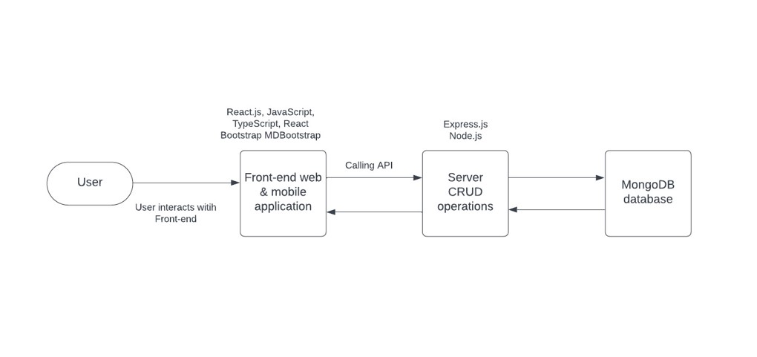

## User Stories – a general explanation of a software feature written from the perspective of the customer.

|  |  |  |  |  |
| --- | --- | --- | --- | --- |
| # | User Story Title | User Story Description | Priority | Additional Notes |
| 1 | Customer Login and registration account | As a customer, I want to be able to login successfully with my existing email and password on the login page or register my details via the registration form on the landing page. After these have been successfully completed, I want to directed successfully to the dashboard page. | High |  |
| 2 | Search for Meals | As a customer I want to be able to search for meals in the search bar and type in my search that will filter and produce the appropriate results. | High |  |
| 3 | Customers can add orders to the shopping cart and remove items from the cart | As a customer, I want to be able to add orders successfully to the shopping cart and remove them. | High |  |
| 4 | Customers can make a payment | As a customer, I want to make a payment in a secure payment gateway system that provides multiple payment methods. | High |  |
| 5 | Customer can leave feedback via a rating system or by submitting their feedback via a form. | As a customer, I want to leave feedback so other users can know about the quality of the meals but most importantly, let the staff know about what improvements they can make. | High |  |
| 6 | Customer can contact support team | As a customer, I want to be able to contact a member of the support team if anything goes wrong during payment. | High |  |
| 7 | Customers can see some educational content about healthy eating | As a customer, I want to be able to view educational content about healthy eating, the strategies utilized to combat unhealthy eating habits. | High |  |
| 8 | Customers can check for any upcoming events for staff that promote healthy eating | As a customer, I want to know if my employer has any upcoming events that help staff members get fit and what sort of healthy recipes | High |  |
| 9 | Customers can update their details | As a customer, I want to be able to update my own personal details such as changing my password or email address. | High |  |
| 10 | Customers can see the total price in the shopping cart and proceed to checkout | As a customer, I want to be able to see the total cost of the meals I have added to the shopping cart before proceeding to the checkout | High |  |

User Flow

Present as a flow diagram the steps a user may make in interacting with the software.

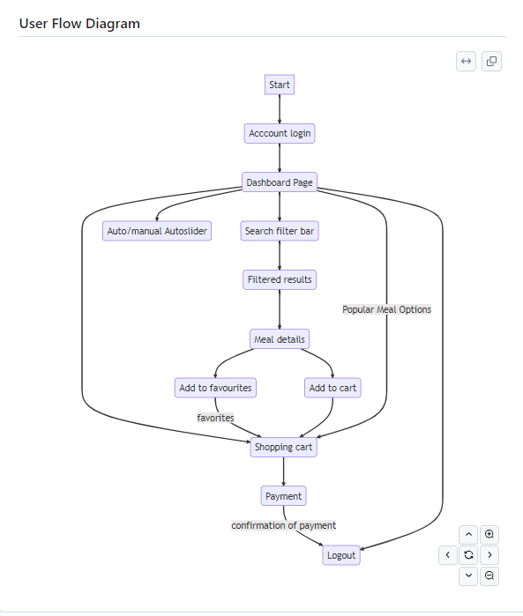

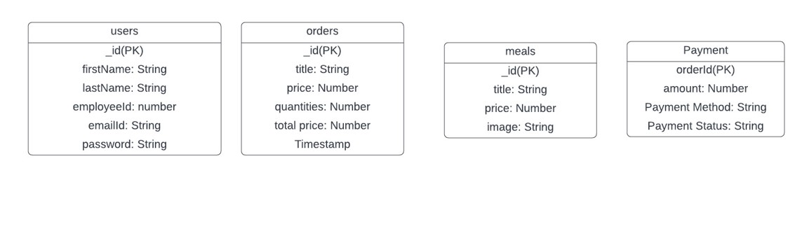

## Wireframe Design

Show elements of the user interface, either manually or via a tool such as Figma.

<https://www.figma.com/file/eXC3KGwNWiIYEjw46u0ZNE/Capstone-IOD-project?type=design&node-id=0%3A1&mode=design&t=DGerSc32avtH2dRu-1>

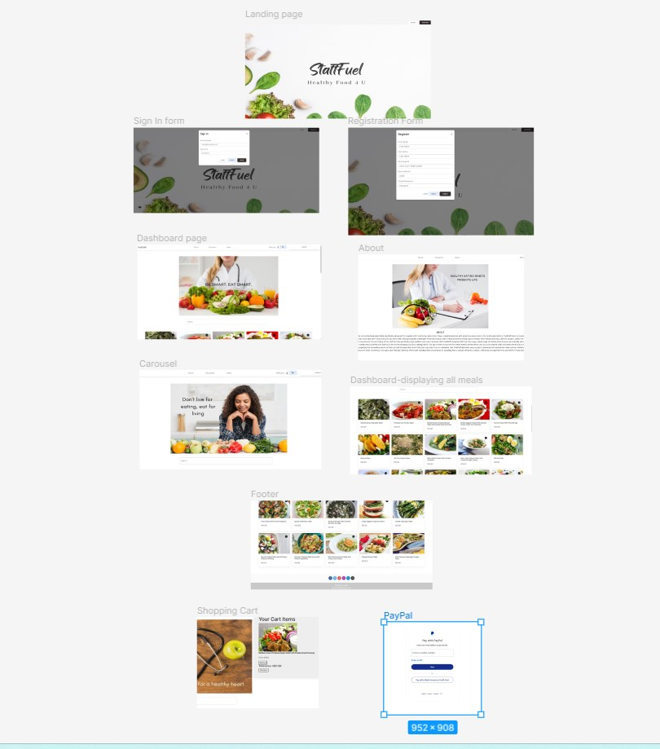

## Open Questions/Out of Scope

What features are considered out of scope?

* Food preparation tracking system
* Fallback payment system option
* Rewards and loyalty programs
* Offering multi-language support
* Meal reviews and ratings
* Chatbot support for customer support
* Integration with social media apps
* Multiple payment gateways

## Non-functional Requirements

* **What are the key security requirements? (e.g. login, storage of personal details, inactivity timeout, data encryption)**

Password encryption, user timeout to prevent unauthorized requirements, storage of customer details in a database backend.

* **How many transactions should be enabled at peak time?**

The online food application should be able to manage concurrent requests and transactions at peak times.

* **How easy to use does the software need to be?**

It needs to be relatively easy to use for all users. The interface must be user friendly and the navigation must be easy for users of all backgrounds with variable levels of tech experience, to use.

* **How quickly should the application respond to user requests?**

To provide a seamless and optimal shopping experience, the software application should respond to user requests as quickly as possible. The application response time should be less than 5 seconds.

* **How reliable must the application be? (e.g. mean time between failures)**

The software must be 100% reliable with close to 100% uptime. User authentication must be reliable when users sign in with the login form or register with the registration form. This is because the users personal information are being used.

* **Does the software conform to any technical standards to ease maintainability?**

The software conforms to industry best practices by using the most up to date technology stack, such as Next.js 13. To ensure other developers can understand the code and change it to optimize the software for better user experiences and performance, there is a lot of documentation in detail to help developers understand what is written and what is being implemented. The code in the software reflects the MVC structure.

# Project Planning

Include a Gantt chart or screenshot of a Trello board showing key milestones (with dates) to complete the project.

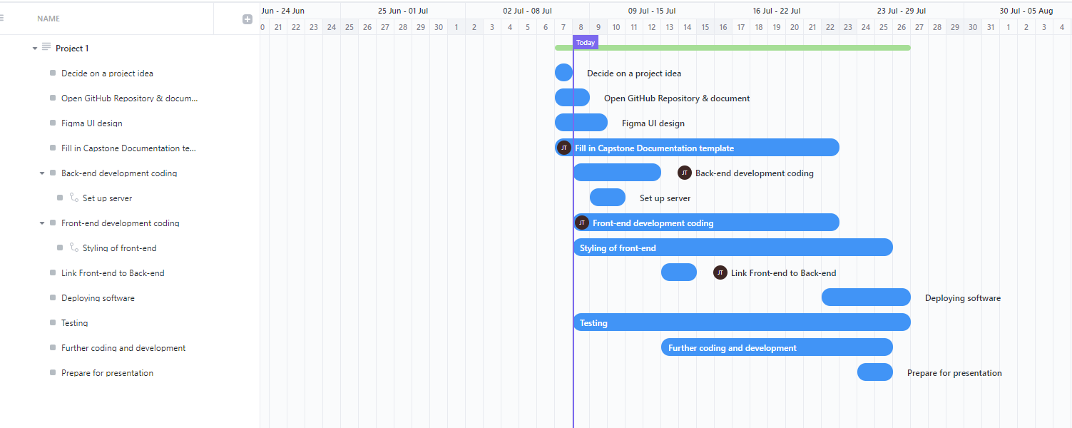

# Testing Strategy

* **What were steps undertaken to achieve product quality?**

Testing of the software was abundant throughout the software development process. Individual components were tested to make sure they were working effectively. This involved using a combination of tools to verify components were working correctly, such as Chrome developer tools, VS code terminal to check for error messages and using the database to make sure data showed up in the database.

For example, with the login form on the landing page, if the user’s email account already exists in the database and if the password is correct, then the user is navigated to the dashboard page. If the user’s email did not exist, the user will be asked to register and go to the registration form instead.

* **How was each feature of the application tested?**

1. Successful Login via the login form on the landing page

This feature was tested by making sure that user’s with an existing email address and password could sign in right away and be taken to the dashboard page. If not successful, users would be asked to register instead.

1. Successful registration via the registration form on the landing page

Successful registration for new users meant that new users’ details could be added to the MongoDB database and could sign in successfully. If user’s details already existed, using either the same email address or employee ID, then an alert message would pop up and say the user’s details already exist.

1. Signing out

Successful sign out meant that the user was redirected back to the landing page with the sign in form.

1. Shopping cart

The shopping cart was tested to make sure the users could add items, remove items and that the shopping cart could calculate the total price accurately.

1. Search bar

The search bar on the dashboard page was tested to make sure that whatever results the user typed in the search bar would return relevant results for their different queries.

* **How did you handle edge cases?**

For the login and registration form on the landing page

* Edge case: Users attempting to submit the forms without any valid data.
* Handling: To handle this edge case, an error message would be displayed to the user to that they need to enter a valid email address or password. For the registration forms, the user would be told they need to complete all parts of the form and not miss any details.
* User emails exist – users attempt to register their email using an existing email that is already in use by another account.
* Handling: the user is told via a clear message that the user already exists, meaning they have to use another email address.

**IMPLEMENTATION What were the considerations for deploying the software?**

Because this was an e-commerce application, it would ideally be hosted with a cloud provider like AWS. Other considerations for deploying the software were security (for example, using secure authentication methods for user logins), having backup and recovery (for example, setting up automatic daily backups of the database), monitoring server health and application performance, carrying out usability testing and other comprehensive testing methods to ensure the user’s experience and application itself was optimized, developing user guides for customers on how to use the platform effectively and providing assistance to users to help them with any issues (for example, having a email or virtual chat) and gathering feedback from customers to make further improvements.

# End-to-end solution

* How well did the software meet its objectives?

In terms of time, the software was able to meet 70% of its objectives. It was planned to have this software deployed on Docker however as a result of time management and other constraints this was not able to be achieved by the due date.

Some of the features that were achieved were creating registration and login forms which connected to the back-end, also grabbing information from the server and rendering it to the front-end. I would have liked to use Redux so that employers or other stakeholders can view the software anywhere. However, also due to time constraints and intensity of the course this could not be achieved. After the course, I plan to work on this project and implement Redux to improve the software.

In future I would like to improve on the following for each component

1. Login and registration forms – implement a set number of failed login attempts and an account lockout to prevent attacks, implement password strength requirements such as using a mix of upper and lower case characters, numbers and informing the user about creating strong passwords.

# References

* Where is the code used in the project? (link to GitHub)

<https://github.com/JanineSooThow/Capstone-project>

* What are the resources used in the project? (libraries, APIs, databases, tools, etc)

Frontend

* JavaScript, TypeScript, React.js
* React Bootstrap and <https://mdbootstrap.com/> for styling.
* Using PayPal React for the PayPal section of the application.

Backend

* Node.js
* Express.js
* Axios
* MongoDB

API

I used the <https://rapidapi.com/spoonacular/api/recipe-food-nutrition/> from Rapid API

Database

* MongoDB database

Mermaid for diagrams

Figma for wireframe design

VS code for coding

Git and GitHub for version control

Vercel for deploying the frontend

Deployment

The front end is deployed using Vercel as of now

I hope in the future that the Backend can be deployed using either AWS or Docker